Que> create file with 10 lines with two error lines grep it!

Que> create one directory having 440 access (u[1 0 0] g[1 0 0] o[0 0 0])

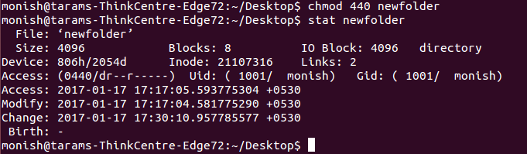

Que> search sudo using "find"

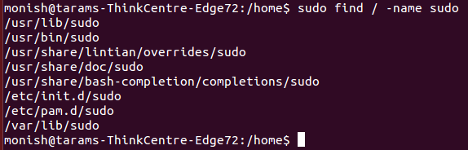

Que> real time log on auth.log file

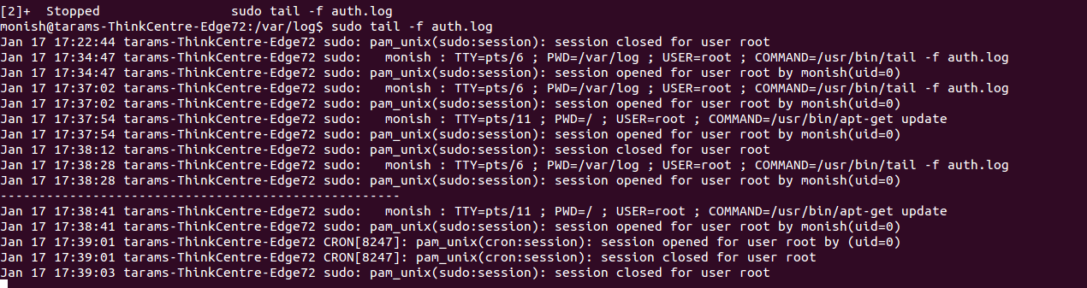
Que> grep first 20 lines

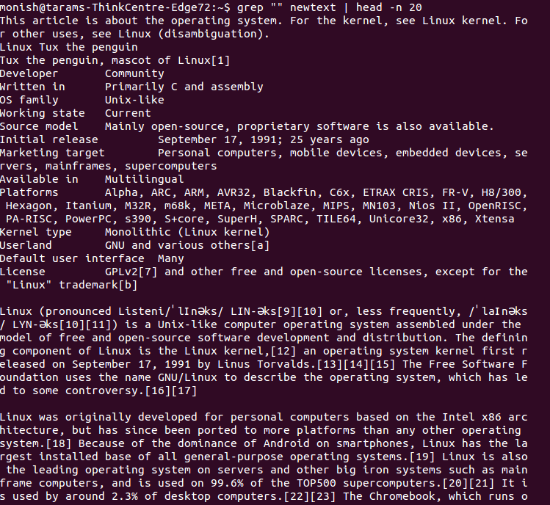

Que> using grep find java services

Que> find portno using netstat

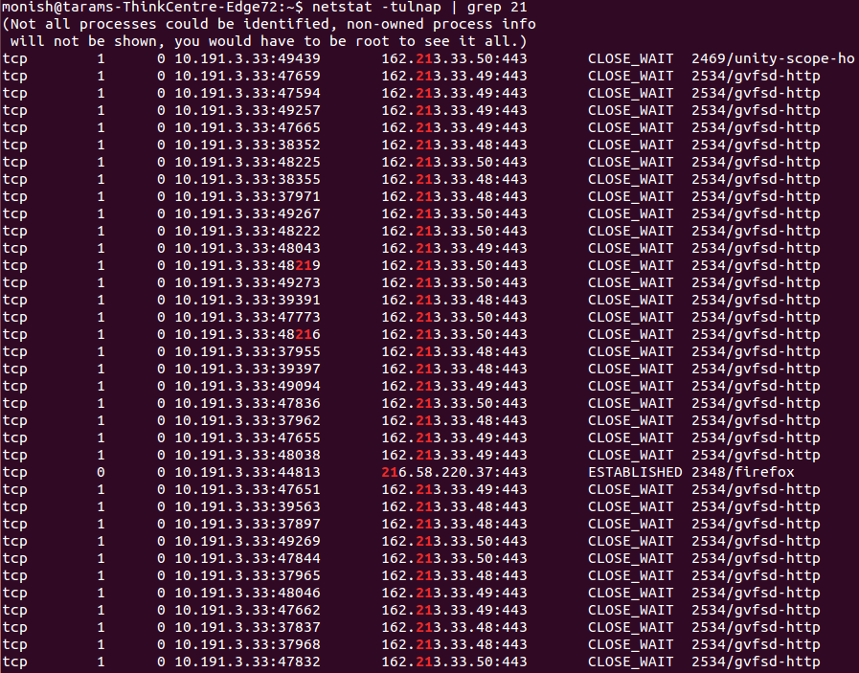

Que> free and top command

